Project – Part I

LAYOUT DESIGN FOR A HYPOTHETICAL FLEXIBLE MANUFACTURING SYSTEM
Responsible Assistant: Büşra Kobya
Due Date: November 27, Thursday, 23:59

1. AIM
The assignment focuses on designing the layout of a hypothetical flexible manufacturing system (FMS). Given the problem description and production data, you will need to develop two design alternatives for the layout and decide on a final design. You will search for the “best” combination of design features.

2. PROBLEM DEFINITION
The hypothetical FMS is assumed to be composed of:
- One vertical milling machine (VMC).
- One horizontal milling machine (HMC).
- One universal milling centre (UMC).
- Two vertical turning centres (VTC1 and VTC2).
- One shaper (SHP).
The block layout of the facility is shown in Figure 1. There are 7 different locations (LOC) that can be used for 6 CNC machines and a central buffer area. The locations of the machines and the buffer zone have not been determined yet. Each machine can fit into an area of 4m x 4m and any of the candidate locations can be used for any machine. The parts to be processed enter the system through a receiving station (R) and completed parts leave through a shipping station (S). These locations are shown in Figure 1.
The transfer of parts among all stations will be carried out by a fleet of automated guided vehicles (AGVs)*. The AGVs can carry one load at a time and they are always routed along the shortest path to their destination. The AGVs travel on the aisles between the machines. The aisles designated as AGV lanes are uni-directional. An AGV can travel in forward direction only and it is possible to load or unload it from both sides. Each location in the layout has a delivery (D) and a pick-up station (P) (or a P/D station which can perform both tasks). AGVs align at these nodes for transferring parts to and from input and output queue spaces that will serve the machine located there. These nodes are located at the mid-points of the lanes (i.e. three meters from each junction). The AGV flow path including lanes, direction of traffic flow on the lanes and locations of the pick-up and delivery nodes are also given in Figure 1.
The input and output queue spaces at machine locations have limited capacities. Therefore, an AGV which tries to deliver at a full input buffer may become blocked and may cause traffic jams that eventually may lead to shop deadlocks. To avoid possible deadlock situations, a Central Buffer (CB) station will be used as temporary storage. In this manner, an AGV that cannot deliver its load at its destination can drop it at CB and pick it up again at a later time to bring it back to the required destination. The location of CB needs to be specified as well.
__________________________________________________________________________________
*You can read about AGVs in https://www.slideshare.net/smit1994/basics-of-agvs-automated-guided-vehicles

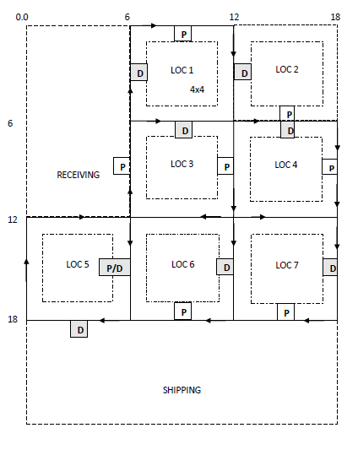
Figure 1: Candidate machine locations together with P and D stations and the AGV flow path

The hypothetical FMS will process a pre-determined set of part types. These part types together with their process plans and hourly arrival rates are given Table 1. Parts are released into the FMS randomly according to the part mix ratio. Table 2 shows assignment of operations to machine centres and the processing time data.

Table 1. Part types and the production rates
Part Type |  | Process Plan |  |  |  | Arrival rate (units per hour)
A | op1 |  | op2 | op3 |  | 6
B | op4 |  | op2 | op5 | op6 | 5
C | op7 |  | op8 | op9 | op10 | 5
D | op11 |  | op12 | op13 |  | 2
E | op14 |  | op8 | op15 |  | 2
Table 2. Machine allocations and processing times
Operation | Machine center | Processing time (sec.)
op1 | VTC1 | 240
op2 | SHP | 120
op3 | VMC | 420
op4 | VTC2 | 260
op5 | VTC2 | 120
op6 | HMC | 300
op7 | VTC1 | 220
op8 | SHP | 90
op9 | UMC | 480
op10 | VTC1 | 120
op11 | VTC2 | 440
op12 | VMC | 300
op13 | HMC | 360
op14 | VTC1 | 150
op15 | HMC | 380

3. TASKS
- Flow and distance matrices
Prepare a distance matrix for AGV trips between the candidate locations. You should be careful while preparing the distance matrix. Each entry should be the shortest path from a location’s pickup node and to-another location’s delivery node. Also prepare a from-to matrix for the required number of material moves among the machines.
- Design of two layout alternatives:
Design two alternative layouts using one constructive and one improvement algorithm. Both alternatives you suggest should be sensible, i.e. obtained as a result of certain methodology that you can explain and justify. You may make use of any relevant analytical or heuristic procedures that you find useful as long as you describe, justify and make proper reference to each. State your assumptions, give a full account of steps or iterations that you performed. Explain every decision in detail.
- Calculation of total loaded distance resulting from a layout:
After deciding on machine placement, multiply from-to matrix with distance matrix to find flow cost of the related layout.
- Comparison and selection:
Compare both layouts by discussing their features. Recommend the better of the two alternatives.

4. DELIVERABLES

4.1. Project Report

0. Information Page
Next to the name, surname, and ID numbers, write the percentage of each group member's contribution to the project and sign it. Unsigned reports will not be accepted. Also, write each member's contributions to the project (i.e. titles, calculations, etc.).

1. Introduction
A brief statement of the problem defined by the case and a brief review of the analysis technique used in its solution. A reader who does not have this assignment description sheet should still understand what you are telling about.

2. Analysis and Solution
The main body of the report where the solution developed is discussed. The analysis procedure from which the design was derived should be logically developed both quantitatively and verbally so that the person reviewing your report will not have difficulty in interpreting various aspects of your design. Include charts, diagrams, drawings and tables whenever necessary. If there are extensive calculations or computer printouts, which are not directly required to follow your solution but provides supporting details, they may be included in an appendix.
This main body may be divided into subsections to bring an easy to follow hierarchy into your report. For example:
…
2.1. Alternative Layout 1
2.2. Alternative Layout 2
2.3. Comparison
or, a similar outline that suits you.

3. Summary, Conclusion and Further Remarks
A concise description of the actual solution proposed for implementation. A brief discussion about the robustness of this proposed design (i.e. relative to future and/or dynamic changes in the process plans or production volumes, or to your assumptions).

4. Appendices (if any)
Should be properly listed, collated, and numbered.
Use a formal language in passive voice, and avoid colloquial style (avoid "I, you, what was going on," etc.). The text portion of the report (excluding figures, tables, and appendices) is limited to 5 pages type-written in Times New Roman, 12 font and 1.5 space. Charts, diagrams, drawings, and tables should have proper captions, readable legends and should be referred in the text as shown in this document.

4.2. Output File & Report Submission
Submit the excel file given to you for from-to and distance matrices you used (and any other data/procedure you used and want to present). Also, submit the soft copy of the project report to the moodle, a hard copy project report will not be received.

5. GRADING
Content: 80%
Content: Completeness, comprehensiveness, methodology, logical development and justification of ideas and decisions.
Report format: 20 %
General quality: Format and organization; language, grammar, and spelling; clarity and conciseness including use of charts, graphs and tables and appendices.
Part 1 Weight: 60%

